**JMeter Distributed**

**Step 1: Explaining prerequisites for JMeter distributed**

* Master and slave machines have JMeter installed with the same versions.
* Master and slave machines must have the same versions of Java.
* Master and slave should connect to a common subnet.
* Open JMeter properties file, add remote host and edit remote_host to 192.168.95.1 as shown below:

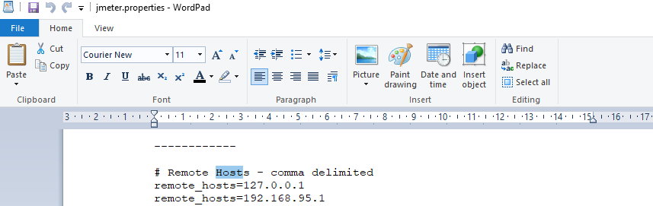

* Run create-rmi-keystore.bat and enter these fields, name:rmi, pwd : changeit.
* Rmi-keystore .jks will be generated automatically.
* Run jmeter-server.bat. 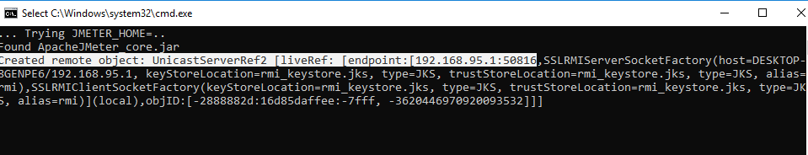

**Step 2:** **Performing distributed testing with JMeter**

* Right click on Test Plan.
* Click on Thread(Users)->Thread Group.

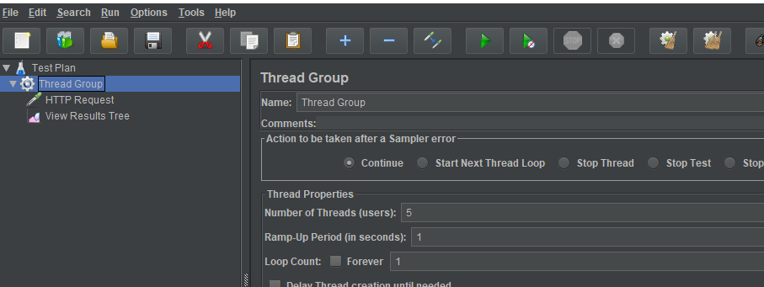

* Right click on Thread Group->Add->Samplers->HTTP Request-> Enter server name “www.google.com”.

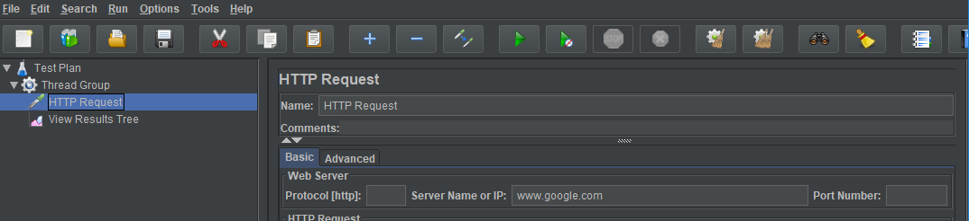

* Right click on Thread Group->Add->Listener->View Results Tree.

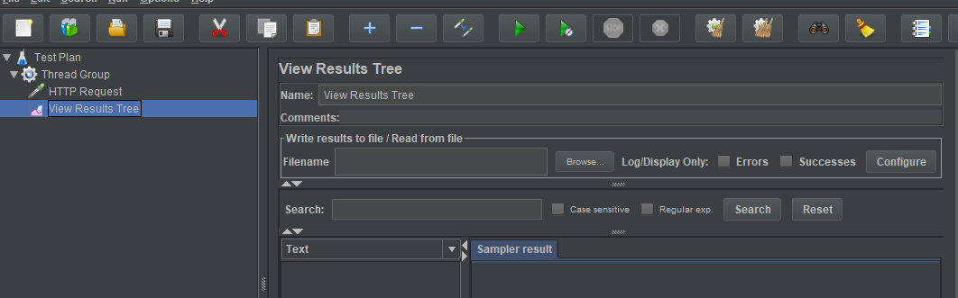

* Run Remote Server.

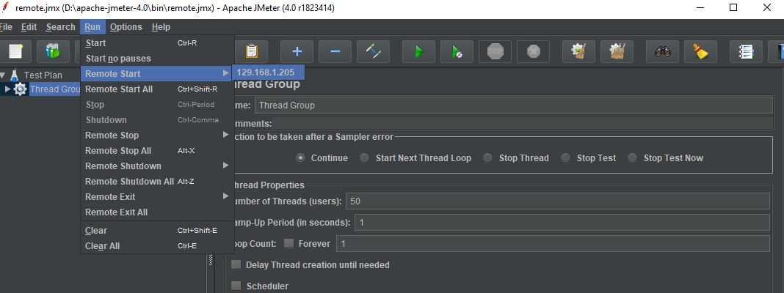

* The screenshot below shows the final result in the tree.

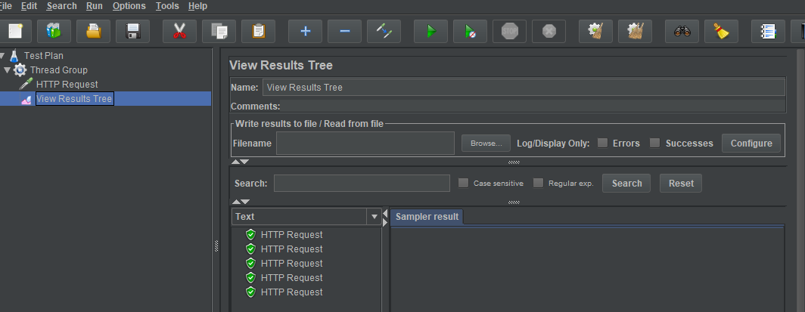

* The screenshot below shows the final result in the server.

